HPE DL360 UEFI Booting

Approach Document
Version 1.1



Customer Restricted - Information that is intended for a restricted set of employees with the right / need to know principle relating to a specific Account engagement where information owned by the client but managed by Capgemini or information related to customers and their environments (both Technology and Business related) is being handled. This classification must be used for Capgemini documentation and systems where information is being shared with the client.

Editing
Verification
Validation

Monitoring developments
Version | Date | Editor | Description
V1.0 | 18-12-2024 | Capgemini Engineering Team | Secure boot for HPE DL360 server, Initial Version
V1.1 | 26-12-2024 | Capgemini Engineering Team | Secure boot for HPE DL360 server, Dependency Auto-Installer v1.1
Table 1: Change history

Distribution
Name | Function | Organization
EXFO Engineering Team | Engineering | EXFO
CG Engineering Team | Engineering | Capgemini
Table 2: Distribution list

Content
1 Introduction 4
1.1 Purpose of the document 4
1.2 Scope 4
1.3 References 4
2 Check secure Boot status 5
2.1 Installing Dependencies 5
2.2 Dependencies 7
2.3 Install sbsign and efi tools: 7
3. Write your own MOK keys 8
3.1 Verifying and Resetting MOK Database 8
3.2 Importing MOK keys 9
4 Building kernel and kernel module 13
4.1 Enable secure boot 14
4.2 Load the kernel module 14
4.3 Writing FPGA bit files 15
5 Stakeholder 18

Introduction

Purpose of the document
The purpose of this document is to provide a comprehensive step-by-step guide to manage Secure Boot on CentOS-7, including generating MOK certificates, signing boot components, and verifying the setup. This ensures system integrity by aligning with UEFI Secure Boot requirements, enabling custom keys and maintaining secure configurations.

Scope
It covers the process of configuring and enabling Secure Boot on CentOS 7. It details creating custom keys, signing boot files, and verifying Secure Boot status.

References
- https://lists.centos.org/hyperkitty/list/announce@lists.centos.org/thread/2APH7YUSNGVRJD5LAXBI46BBB5AKWHZZ/
- https://vault.centos.org/7.9.2009/
- How to boot Linux using UEFI with Secure Boot ? — Get Intimate With Cyber ! 0.1 documentation
- https://access.redhat.com/solutions/10154
- https://www.linuxquestions.org/questions/linux-newbie-8/create-iso-from-centos-7-server-4175653114/#google_vignette
- https://www.linuxquestions.org/questions/linux-newbie-8/create-iso-from-centos-7-server-4175653114/#google_vignette

2 Check secure Boot status
After Flashing OS, switch to root user(su in CentOS 7).
1.To check the current Secure Boot status
mokutil --sb-state
2.Edit the Base URLs in CentOS-Base.repo
vi /etc/yum.repos.d/CentOS-Base.repo
Comment out all mirror URLs by adding a # at the beginning of each line containing mirrorlist.
Add the following baseurl lines under the respective sections:
Under [base]:
baseurl=http://vault.centos.org/7.9.2009/os/$basearch/
Under [updates]:
baseurl=http://vault.centos.org/7.9.2009/updates/$basearch/
Under [extras]:
baseurl=http://vault.centos.org/7.9.2009/extras/$basearch/
Save and exit the file:
Press Esc, then type: wq and hit Enter.
Check the network connection status using
nmcli dev status
If disconnected, reconnect using
nmcli dev connect <interface_name>
then run the following command to update.
yum update
NOTE: Initially, Secure Boot must be under Disabled State.

2.1 Installing Dependencies
Get the files from below link
NOTE: If you don’t have wget command, use the command the belowto install wget.
“yum install wget“
wget http://10.16.128.175/New/Dependencies.tar.gz
wget http://10.16.128.175/New/Kernel.tar.gz
wget http://10.16.128.175/New/install-dependencies.sh
wget http://10.16.128.175/New/lastmile-486cf189.tar.gz
wget http://10.16.128.175/New/racer_0x1000_0x2412_0x0001.bit
wget http://10.16.128.175/New/racer_0x1002_0x2412_0x0001.bit

2.2 Dependencies
Provide executable permissions for install-dependencies.sh file.
chmod +x install-dependencies.sh
Run the script file to install essential tools which involves sbsign , efitools and its dependencies(openssl, dev-tools, libuuid, help2man, perl, git, etc).
./install-dependencies.sh

2.3 Install sbsign and efi tools:
Install sbsigntools:
  - cd Dependencies/secu-os/sbsigntools
  - ./autogen.sh
  - ./configure
  - make check
  - make install
  - make install check

Install efitools:
  - cd ../efitools
  - make
  - make install

3. Write your own MOK keys
To generate your own MOK certificates, use the following command:
openssl req -new -x509 -newkey rsa:2048 -keyout MOK.priv -outform DER -out MOK.der -nodes -days 365 -subj "/CN=Custom MOK Key/”
CN can be any common name
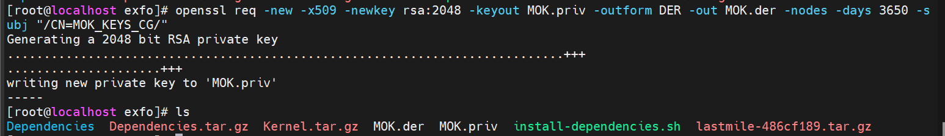
MOK.der and MOK.priv will be created.

3.1 Verifying and Resetting MOK Database
Check If MOK keys are already present in MOK database using following command.
mokutil--list-enrolled
If MOK keys already exists in MOK database. Erase them using following command.
mokutil --reset
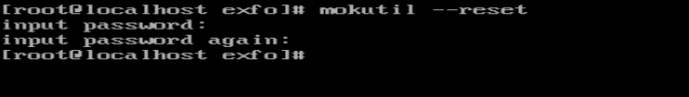
Reboot
Follow MOK management prompts to reset MOK keys.
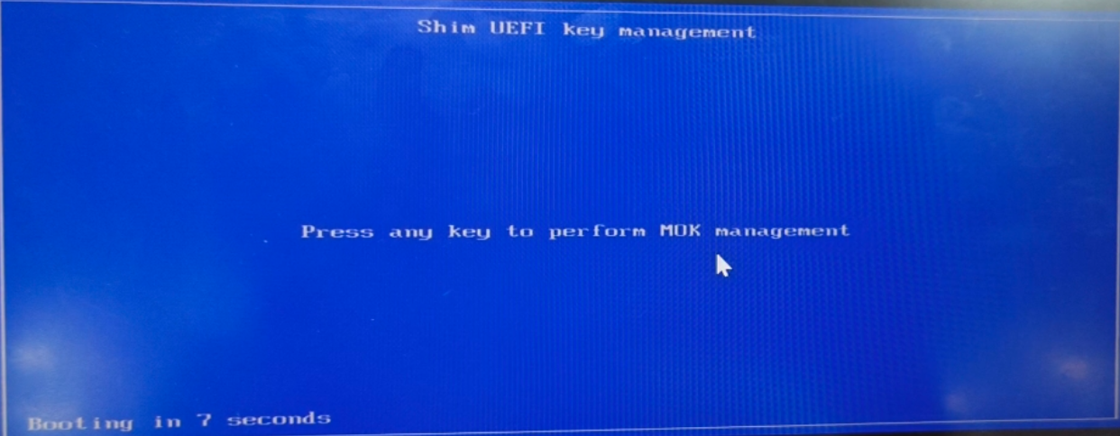
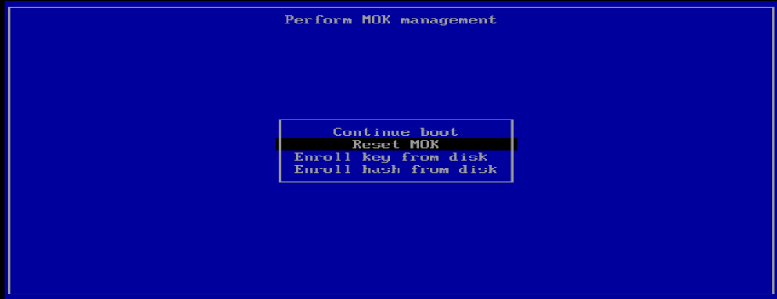
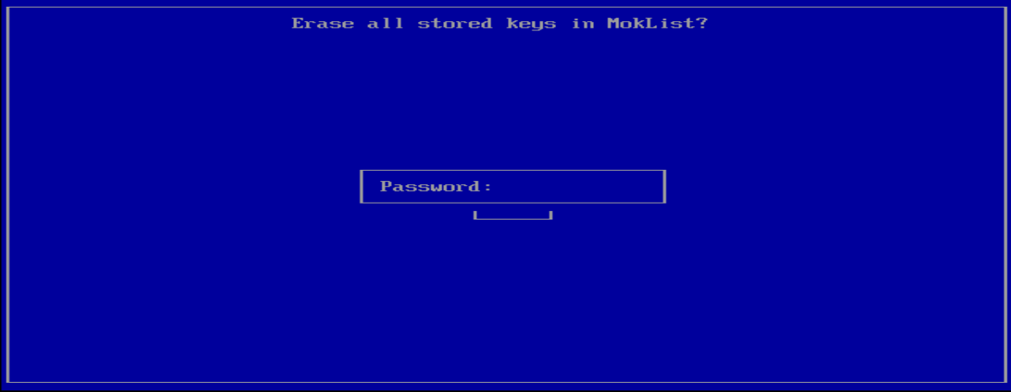
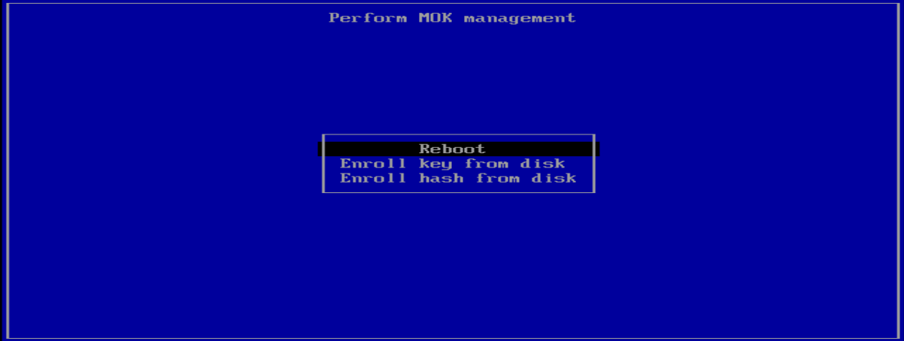

3.2 Importing MOK keys
1.Run following command to import the keys:
mokutil - -import /path/to/MOK.der
It prompts the password Twice, Provide same password both times.
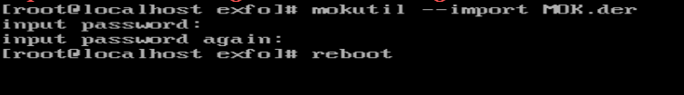
2.Reboot the system and follow on-screen instructions to enroll the MOK keys and provide the password you have created during MOK key importing


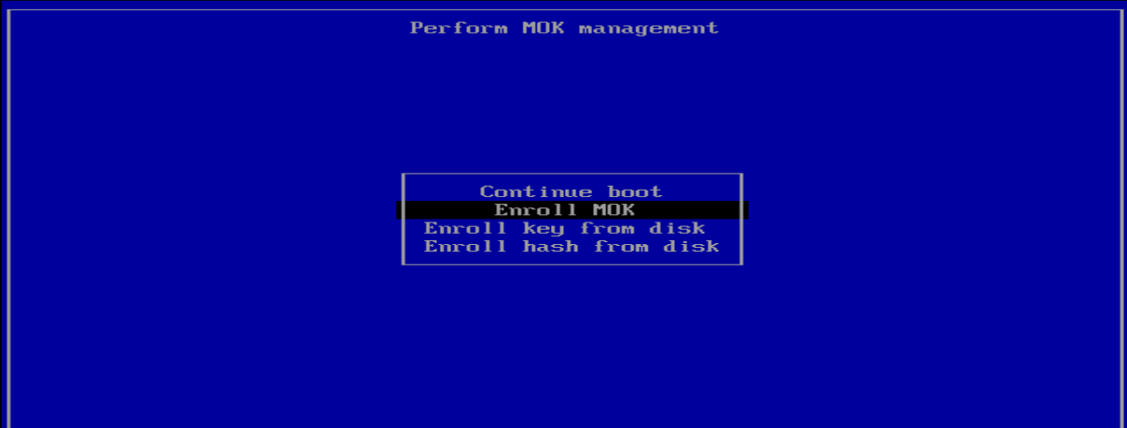



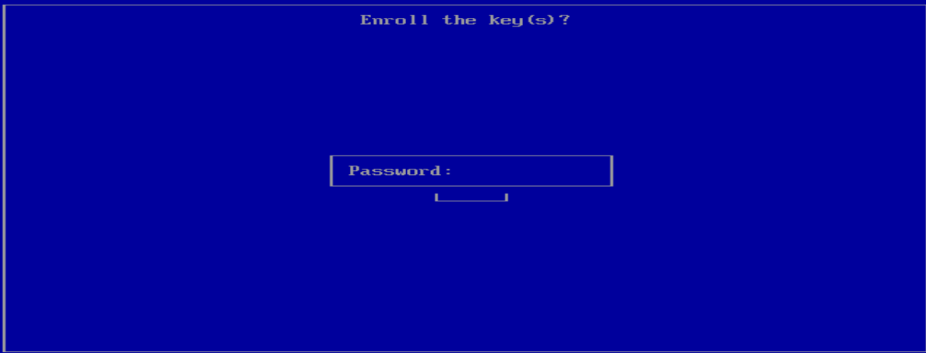
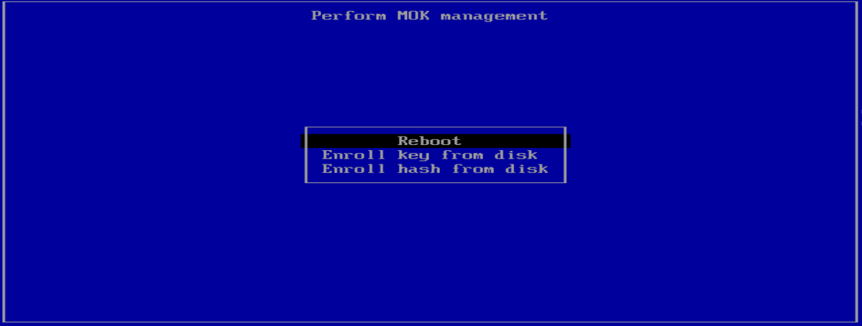

Building kernel and kernel module
Untar the kernel.tar.gz file and run the following command to install the kernel.
tar -zxvf Kernel.tar.gz
cd depKernelSrc
rpm -i kernel-devel-3.10.0-1160.119.1.el7.x86_64.rpm
Untar the lastmile.tar.gz file.
tar -zxvf lastmile.tar.gz
Build the lastmile driver:
cd lastmile/driver
make
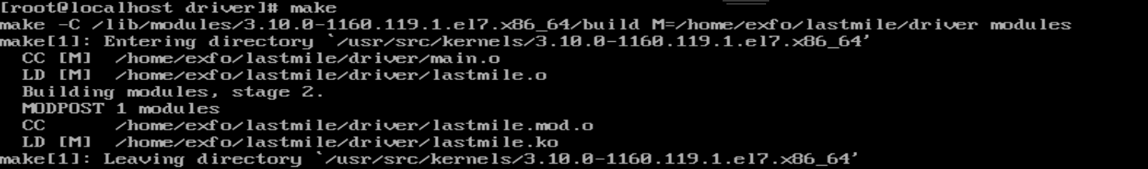
sign kernel:
/usr/src/kernels/$(uname -r)/scripts/sign-file sha256 /path/to/MOK.priv /path/to/MOK.der /path/to/lastmile.ko
Verify if the kernel module is signed with your MOK key using the following command:
modinfo lastmile.ko
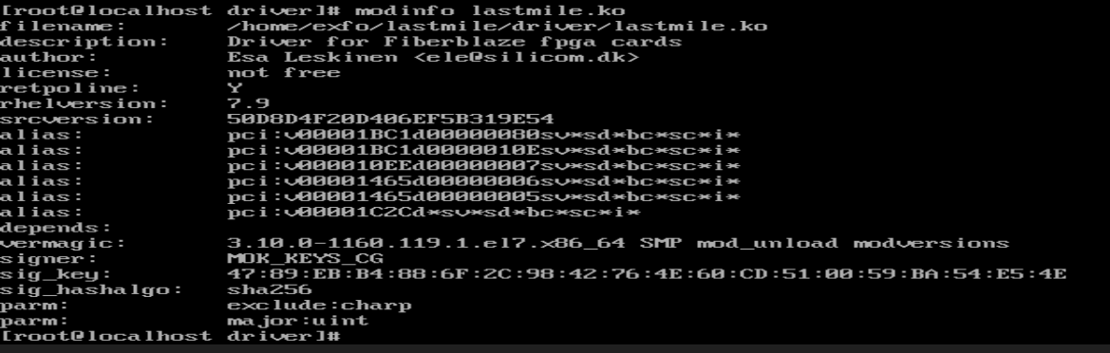

4.1 Enable secure boot
- Reboot the system and press F9 during the boot process.
- Navigate to the following menu:
- BIOS/Platform Configuration > Server Security > Secure Boot Settings.
- Attempt to enable Secure Boot by selecting Enabled.
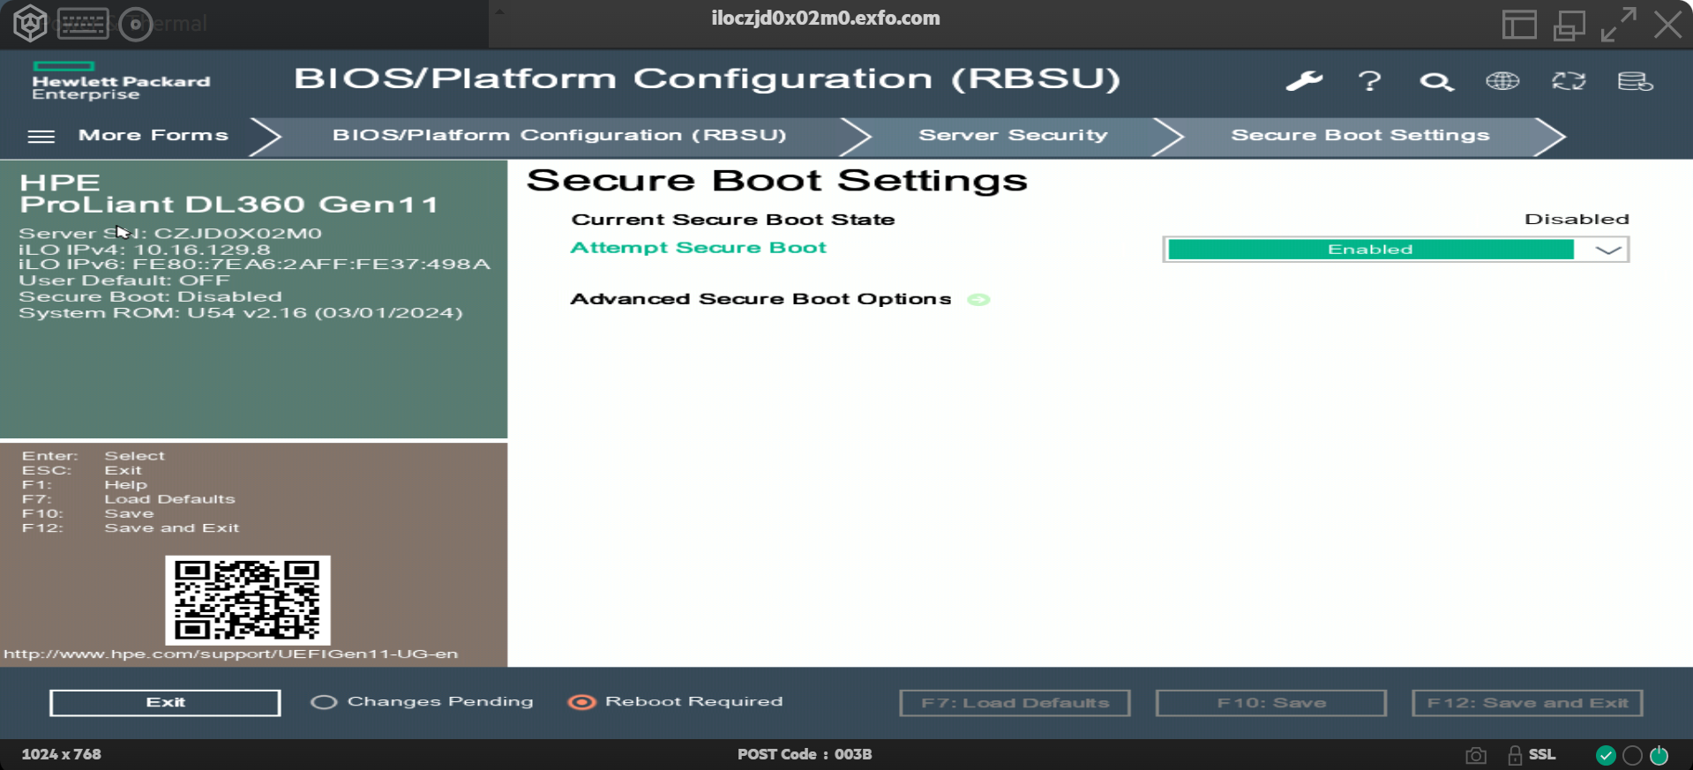
Verify Secure boot status
To confirm Secure Boot is Enabled, Run below command in Centos 7 Terminal.
mokutil --sb-state

4.2 Load the kernel module
./load_driver.sh
Build the rawcardtool utility:
cd ../rawcardtool
make
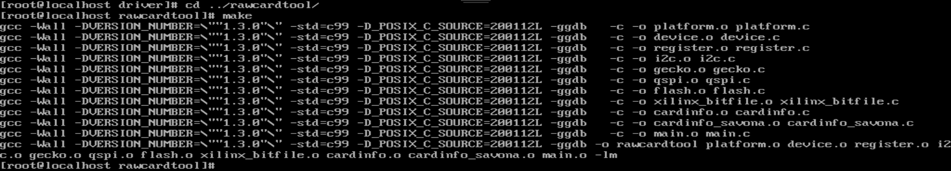
Verify that everything was successful.
./rawcardtool --status
You should see similar output to this:
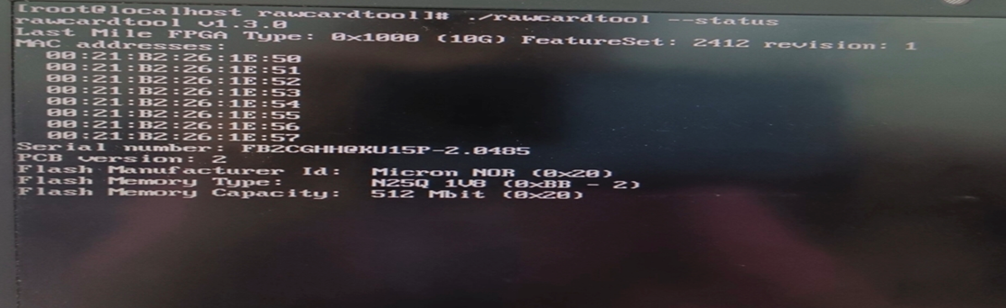

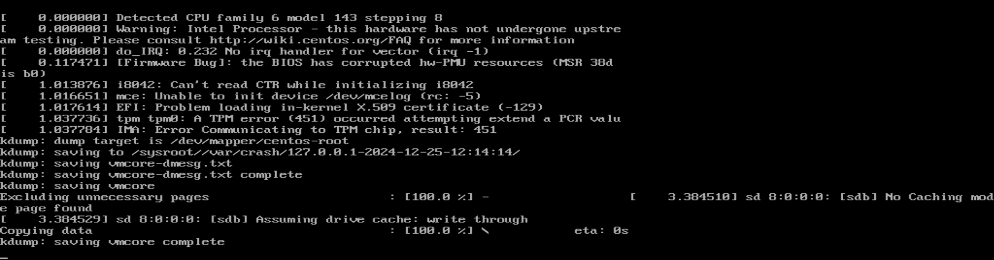

4.3 Writing FPGA bit files
./rawcardtool --flash ../../racer_0x1000_0x2412_0x0001.bit
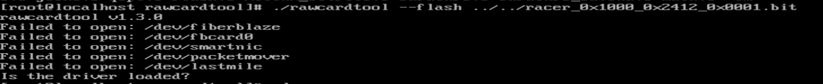
If writing bit fails redo the below steps until you see the following output screen.
- cd lastmile/driver
- make
Verify whether kernel module is signed with your MOK key or not using follow command.

modinfo lastmile.ko

Note: Sign the module only if the signature is not validated; skip step 3 if the signature is already valid.

- /usr/src/kernels/$(uname -r)/scripts/sign-file sha256 /path/to/MOK.priv /path/to/MOK.der /path/to/lastmile.ko
- ./load_driver.sh
- cd ../rawcardtool
- make
Write the Bit after redoing above 1-6 steps
./rawcardtool --flash ../../racer_0x1000_0x2412_0x0001.bit
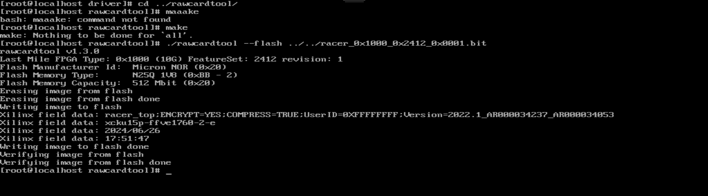
At this point, the server needs to be rebooted in order for the FPGA card to work. Unfortunately, that means redoing steps 1 to 6 under server setup above. This is required because the factory PCI BAR size is 128KB but the new FPGA load has a BAR size of 250MB. Reboot the server by writing into the terminal:
sudo reboot
Verify that the FPGA write was successful:
cd rawcardtool
./rawcardtool –status
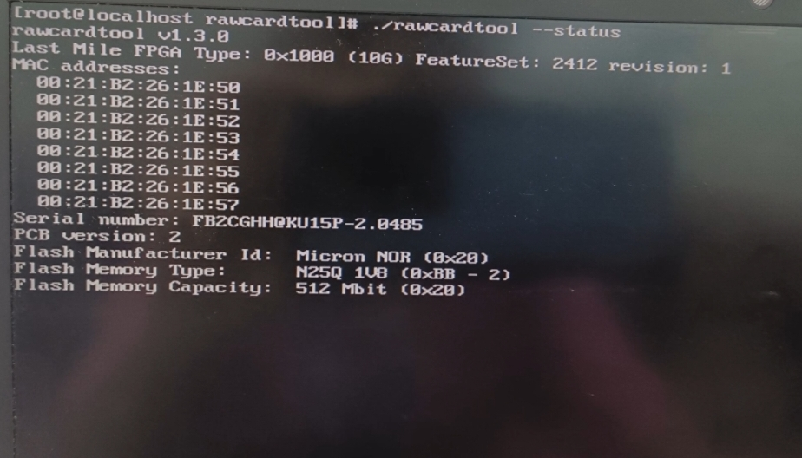
Note that the FPGA Type, FeatureSet and revision correspond to the name of the flash file. If you see the same output as before writing the flash, STOP! That means that the card is not properly encrypted, and it loaded the failsafe instead of the primary flash because of that. To continue, the card must be properly encrypted and the rawcardtool status must show the output above. Once that is done, rawcardtool --status will output the correct text above.
Write the failsafe flash ONLY IF the primary flash was successfully verified in the previous step
./rawcardtool --flashsafe ../../racer_0x1002_0x2412_0x0001.bit
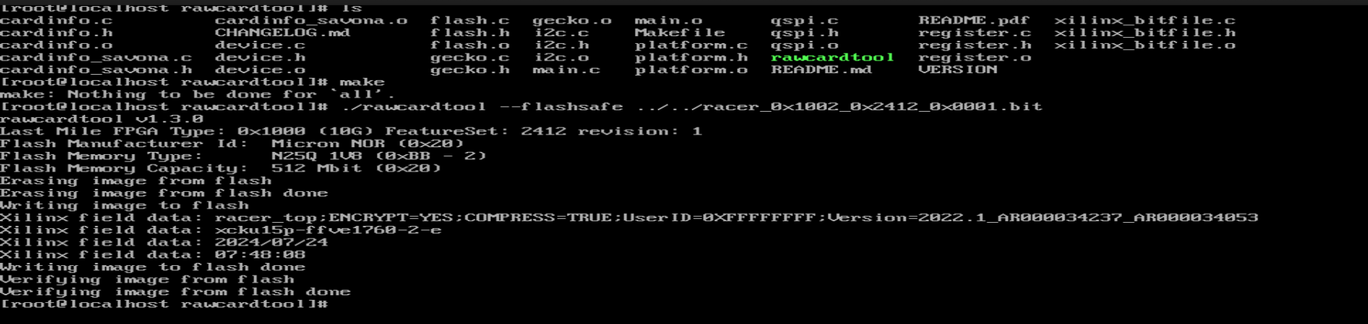
Reload the FPGA from the flash we just wrote:
cd ..
./reload_from_flash.sh failsafe
Verify that it was successful.
cd rawcardtool
./rawcardtool –status


NOTE: All the above steps need to be performed as a root user.

Stakeholder

Name | Function | Title
Kesavan,Nivetha | Project Manager | Project Manager
Vijayan Bharathi | Delivery Manager | Director
Suresh Kalidasan | Architect | Architect
Navyasree | Software Developer | Engineer
Jhansi Vaddipalli | Software Developer | Engineer

About Capgemini Engineering
Capgemini Engineering combines, under one brand, a unique set of strengths from across the Capgemini Group: the world leading engineering and R&D services of Altran – acquired by Capgemini in 2020 - and Capgemini’s digital manufacturing expertise. With broad industry knowledge and cutting-edge technologies in digital and software, Capgemini Engineering supports the convergence of the physical and digital worlds. Combined with the capabilities of the rest of the Group, it helps clients to accelerate their journey towards Intelligent Industry. Capgemini Engineering has more than 52,000 engineer and scientist team members in over 30 countries across sectors including aeronautics, automotive, railways, communications, energy, life sciences, semiconductors, software & internet, space & defence, and consumer products.
Capgemini Engineering is an integral part of the Capgemini Group, a global leader in partnering with companies to transform and manage their business by harnessing the power of technology. The Group is guided every day by its purpose of unleashing human energy through technology for an inclusive and sustainable future. It is a responsible and diverse organization of 270,000 team members in nearly 50 countries. With its strong 50-year heritage and deep industry expertise, Capgemini is trusted by its clients to address the entire breadth of their business needs, from strategy and design to operations, fueled by the fast evolving and innovative world of cloud, data, AI, connectivity, software, digital engineering and platforms. The Group reported in 2020 global revenues of €16 billion.
Get the Future You Want | www.capgemini.com





This document contains information that may be privileged
or confidential and is the property of the Capgemini Group.
Copyright © 2022 Capgemini. All rights reserved.

